Chapter 13, Problem 18.

Find the Thevenin equivalent to the left of the load Z in the circuit in Fig. 13.87.

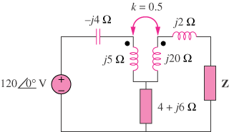

Figure 13.87
For Prob. 1318.

